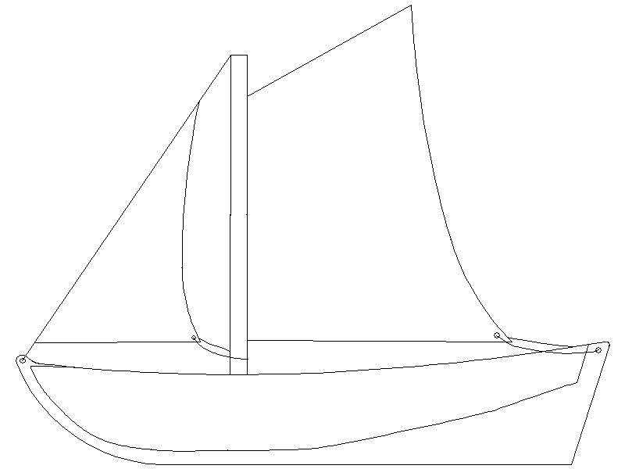
How to Build a Bristol Channel Pilot Cutter
Just like building a traditional wooden boat your boat will have a strong backbone and ribs around which you wrap a skin of watertight planks.
This basic structure has three main parts-

1. Double centre pieces to make the keel
2. Large bulk head (frames) which slot onto the middle of the keel
3. Smaller transom (end frame) which slots onto the stern of the keel

All parts are fixed with gummed tape. The basic structure is then added to with -
- Cardboard planks, three to each side to create the hull.
- Gummed tape to seal it.
- A mast is inserted.
- A deck is added to the top of the planks
- Rig and set sails
- Waterproof the hull
- Ballast your boat.
It is important that your boat is symmetrical. What happens on the left side must be mirrored on the right side. Which means that each left plank is the mirror image of a right plank.
The corrugated board has a shiny side and a dull side. The shiny side goes on the outside of the boat.
Gummed tape -Instead of nails and bolts and caulk the boat is joined and sealed with gummed tape. Practice using this tape. Cut with scissors to the sizes you need, do not be tempted to tear the tape. Use a sponge in a shallow amount of water so that you can make the glue side wet. Practice getting this right. Too dry or dry in parts and the boat will have holes, too wet and your boat will turn soggy while you build. The tape will slide when wet and should be held in place to dry. Hold it for longer if the joint is under tension. Working with a team that cuts, wets, sticks, holds and conducts quality control is the best way to work.

Stage 1 – The Keel
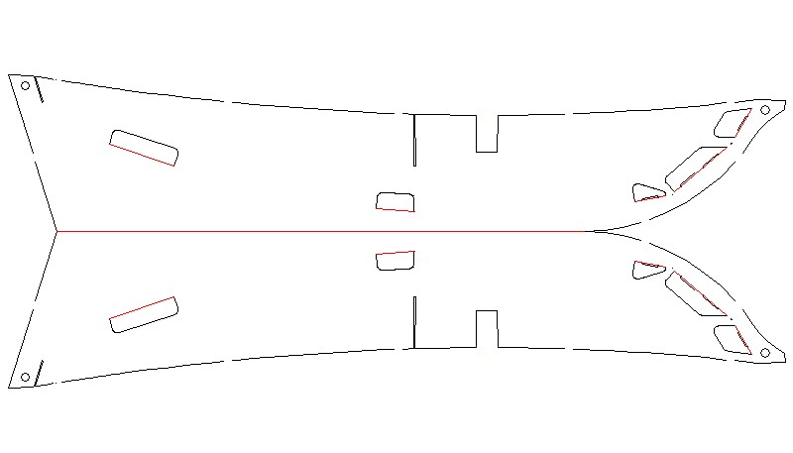
- Gently fold all the tabs out so they stick out on the shiny side
- Bring the two together with their shiny sides out
- Hold them firmly together using gum tape around the bottom edge and sides.
- Leave no gaps and cut tape to size. Longer strips of tape will work on a straight edge but smaller bits are needed around the curved bows
- Inspect the work and replace tape that has been poorly fixed
- On the top edge use the tape at the front (Bows), back (stern) and either side of the slots for the bulk head and mast
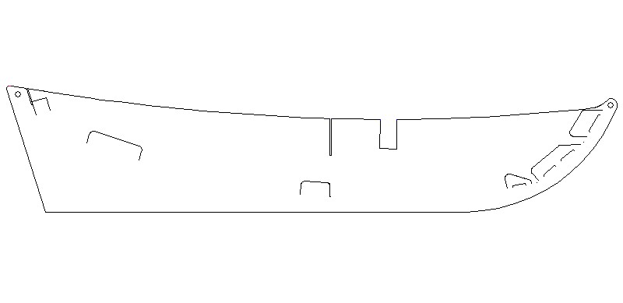
Mast slot
Bulkhead slot
Transom slot
Bow tabs
Tab 2
Tab 1
Push the bulk head (main frame) gently but firmly into the narrow slot in the centre. Do the same with the transom at the stern (rear) with white side facing out. Fold down the top flaps on these parts so they fit down onto the sides of the keel at a 45 degree angle and fasten into place with gum tape. Seal the gaps between the keel and the transom with tape. Fold the tabs around the bottom of the transom inwards ready to help you locate the planks.
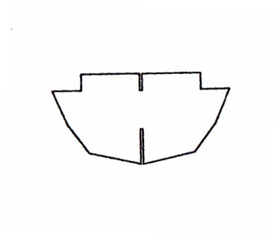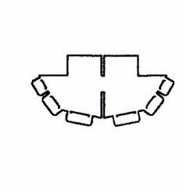
Main frame Transom

Turn the keel upside down ready for the planking.
Stage 2 - Planking
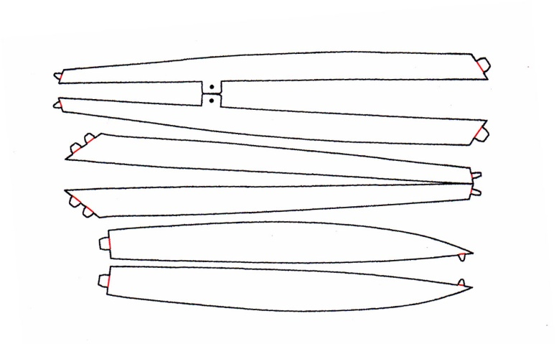.
Bottom Planks
Top Planks
Middle Planks
- Take one of the bottom planks. Test the fit from the tab on the transom following the tabs sticking out of the keel. The straighter side of the plank will fit to the keel when curved around these tabs. Make sure it is shiny side out.
- Tape the square end of this plank to the transom
- Tape the square end of the plank to the straight edge on the bottom of the transom.
- Gently bend the plank over the main frame and over the two large tabs sticking out of the keel, keep the straighter inside edge of the plank tight against the keel centre piece and keep the tabs inside the boat. Hold tab 1 and the plank tight and use a 700mm (7cms) tab of gum tape to hold it in place against the keel. Repeat with Tab 2. This will give you the correct curve.
- Repeat with on the other side of the keel.
- The tip of these two planks will line up with the tab coming out of the keel at the bow (front).
- You can now tape these planks to the keel all the way along. Start at the back and use appropriately sized pieces of tape. Overlap the tape by about 10mm (1cm). Water will penetrate any hole or poorly fixed tape.
- Be careful to maintain the curve that this plank makes. It is easy to shift the curve when pressing on the tape. Two pairs of hands are useful at this point.
- You don’t need to tape the very tip the plank to the tab at the bow until other planks are in place.
- Check alignment for symmetry as you go.
Now take one of the middle planks in the illustration above-
- It is easy to put the planks on the wrong way around – look at the way the bows will be shaped before fixing them in place.
- Start at the stern and tape the smaller straight end of this plank to the straight edge in the middle of the transom. The bottom edge of this plank will line up with the top edge of the previous plank along its whole length. This is a butt joint and there is no overlapping of the planks. Tape it into position with sections of tape. Longer lengths of tape can be used where the join line is straight. Tape size will vary from 50mm (5cm) to 250mm (25cm)
- Repeat the process on the other side.
Now take one of the top planks in the illustration above-
- Repeat this process with the top two planks. The lugs on the top plank are towards the rear (stern) of the boat.
- It is easier to turn the boat over to secure the top plank.
- Check the work. Removing and replacing any tape that is poorly fixed.
- Taping the inside has no benefit a secure and sealed exterior is needed.
On a real boat the sealing process between planks is called caulking and it uses cotton wadding and pitch (tar) between the planks.
Stage 4 – Mast and Deck
- Take the flat mast section and lay it shiny side down. Using a blunt pencil to score the corrugations along their whole length. This will enable you to roll the card into a tube.
- Once it is rolled up hold it while someone straps the tube edge to edge (no overlap)
- Join neatly with a length of gummed tape from the top of the mast to the two slots that will become apparent as you make the tube.
- This is now your mast and should be slotted into the mast slot in the illustration above.
- Tape this firmly ensuring it is fixed right at the base.
- Now take the deck and gently push the top of the mast through the hole in the deck and then work the deck gently down the mast to meet the edges of the top planks. Push the deck down until it pushes out the top plank and hold it in place.
- Team work is needed here. Starting at either side of the two lugs on the top plank. Push the deck just enough to sit inside the planks. Use 50 mm strips of gum tape to stick the deck and plank edges together, over lapping the tape as you go. Do not cover the holes for the rigging.
- Then gum tape around the bottom of the mast to the deck. To do this neatly the tape needs to be cut in thin strips.
- Use the hole from the deck to seal and strengthen the top of the mast. Thin strips are needed again for this.
Stage 5 – Rigging
The rigging holds the mast up and gives a strong fixing for the sails.
- The first part of rigging is the main stay. Take a piece of string about 1.5m long. Find the middle by folding it in half and tie the middle firmly to the top of the mast with a reef knot, sticking it with gummed tape around the top of the mast. Then tie each end of the string to the holes in the top plank each side of the hull, making sure that the string is tight. Use a hitch knot to fasten so that you can adjust the tension. A hitch knot can be pinched to prevent it slipping while you tie it off.
- The second part is the fore stay. Take a 0.75m piece of string and tie it with a reef knot above the knot for the main stay. Stick it down to stop it sliding down the back of the mast with gummed tape. Thread the string through the hole in the bow and use another hitch to pull the mast tight against the main stay. If you put a loop in the standing rope then thread it through the hole in the bow and back up to the loop your hitch knot will be easy to manage and you can adjust tension.
- The stays pull the mast backwards, forwards and side to side (port to starboard). As you apply tension to the stays check to see if the mast is pulled vertical.
- Tension is relative to the strength of the cardboard so don’t overdo it.
Stage 6 - Sails
Decorate sails to suit before fixing to the mast.
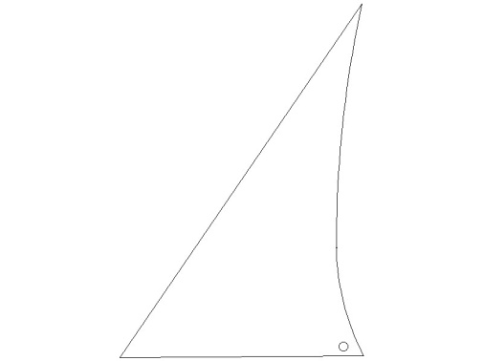
Mast
Fore stay

Fore sail.

- Take the fore sail and use a strip of tape to stick it along the fore stay so that it is held above the deck.
- Loop a piece of string through the hole in the foresail and around the mast. Don’t tie this tightly but allow the sail to move from side to side, just as far as the deck edge, so it can catch the wind. Look at the drawing of the boat.

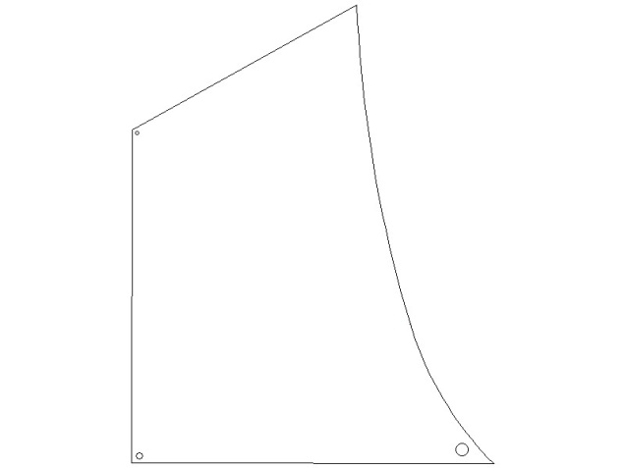

Main sail.

- Take a 250mm (25cm) length of string and tie it around the mast above the knots for the stays. Use the tails from this knot to tie the main sail to the mast using the two holes in the straight edge of the sail.
- Make sure the sail doesn’t touch the deck. Stop the knots from sliding down the mask with gummed tape.
- As with the fore sail make a very loose loop through the hole in the sail and the hole at the stern as you did for the foresail. This loop will allow the sail to move over to the rigging on both sides.
Decorate and name your boat.
Waterproofing, Ballasting and Decorating your boat
- Waterproofing
You must seal the hull of your boat completely with the gum tape, so that there is no hole or gap. Then, when all the gum tape is dried, you can paint the entire hull below the deck with a water-proof paint, varnish or resin. Don’t skimp on it, cover everything well and then set it upside down to dry.
- Ballasting.
Ballasting is essential for your boat. Without it your boat will fall over in the water by the weight of its mast and sails.
Ballast is weight that we put low down into the boat to counter-balance the top weight of the masts and sails and the force of the wind on them. Getting the balance of ballast, wind and sail setting is the mark of a good sailor.
Light ballast | - Survive light winds  - Ride high in the water  - Sail faster
Heavy ballast | - Survive stronger winds  - Sink deeper in the water  - Sail slower
Uneven ballast | - Boat leans to one side  - Sails in a curve rather than a straight line

- Use kiln dried sand to ballast your boat.
- Put four cups of sand through the hatch in the deck. One cup in each of the four compartments. Add more sand if it is very windy.
- The boats can take quite a weight of ballast, up to 6 kilos, that’s the same weight as 12 tins of baked beans, that is a lot of sand; you won’t need that much.
- Launch the boat carefully so that the ballast is in the middle of the boat.
- It will not sail directly down wind. It will sail across the wind at an angle determined by how tightly you rigged the sails.
www.myfuturemychoice.co.uk
@ MF_MC info@myfuturemychoice.co.uk
Instruction video – scan QR Code

